**Module 1 System of forces**

1. Determine the resultant of the three concurrent forces shown in Fig.

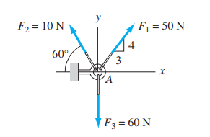

2. Two men are trying to roll the boulder by applying the forces shown in figure. Find the magnitude and direction of the force that is equivalent to the two applied forces.

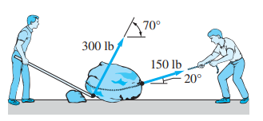

3. The magnitudes of the three forces applied to the eye bolt are T1 = 110 N, T2 = 40 N, and T3 = 150 N. Replace these forces with a single equivalent force R. Show the result on a sketch of the eye bolt.

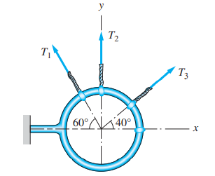

4. Determine P and θ so that the three forces shown are equivalent to the single force R = 85i + 20j kN

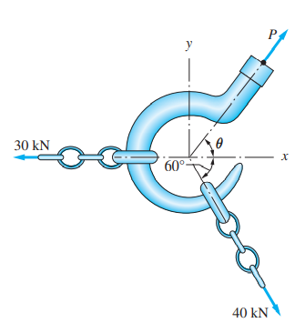

5. The force R is the resultant of the forces P1, P2, and P3 acting on the rectangular plate. Find P1 and P2 if R = 40 kN and P3 = 20 kN.

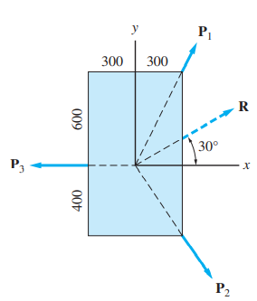

6. The resultant of the three concurrent forces acting on the eyebolt is the force R = 800j lb. Determine the magnitude of the force P and the angle θ that specifies the direction of the 900-lb force.

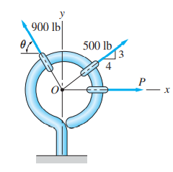

7. For the collar shown in figure, determine (a) the required value of α if the resultant of the three forces shown is to be vertical, (b) the corresponding magnitude of the resultant.

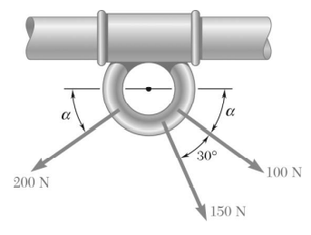

8. A hoist trolley is subjected to the three forces shown. Knowing that α = 40°, determine (a) the required magnitude of the force P if the resultant of the three forces is to be vertical, (b) the corresponding magnitude of the resultant.

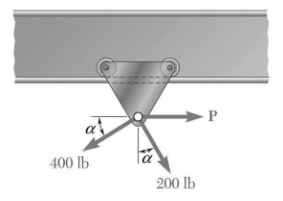

9. A hoist trolley is subjected to the three forces shown. Knowing that P = 250 lb, determine (a) the required value of α if the resultant of the three forces is to be vertical, (b) the corresponding magnitude of the resultant.

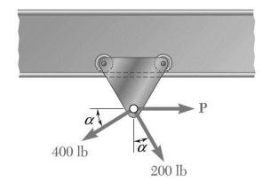

10. Two cables tied together at C are loaded as shown. Knowing that the maximum allowable tension in each cable is 800 N, determine (a) the magnitude of the largest force P that can be applied at C, (b) the corresponding value of α.

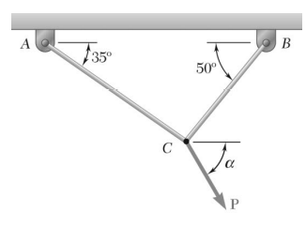

11. Determine the resultant xof four forces acting on a body as shown below

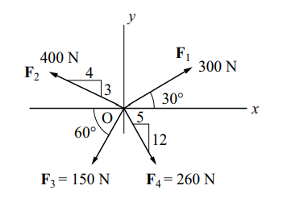

12. If the magnitude of the resultant force acting on the bracket is to be 80 lb directed along the u axis, determine the magnitude of F and its direction.

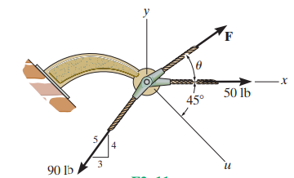

13. Find the force in the cable 0A, if the resultant of the forces at 0 is acting vertically. What is the magnitude of the resultant?

(Ans: TOA = 32.35 KN, R = 52.54 KN )

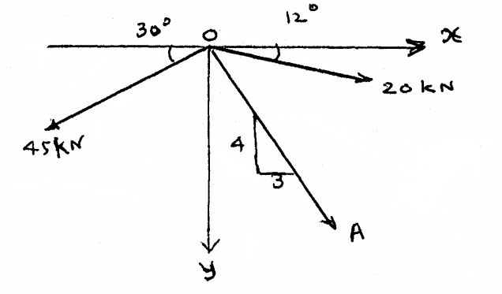

14. A force R = 25 KN acting at 0 has three components, FA, FB and FC as shown in fig. If FC=2OkN, find FA& FB .

(Ans: FA = 33.9 KN, FB = 35.03 KN )

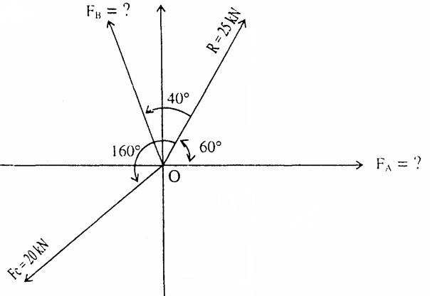

15. Find out the magnitude of the force P4 and the direction of force P3 if the resultant of four coplanar concurrent forces P1, P2, P3 & P4 as shown in fig. is zero.

(Ans: P4 = 9.51 KN, θ= 87.13° )

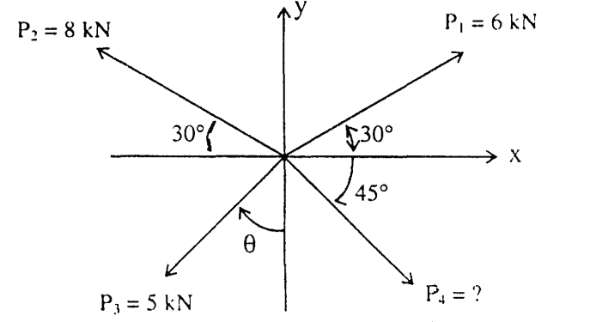

16. Three coplanar forces act at a point on a bracket as shown. Determine the value of the angle α such that the resultant of the three forces will be vertical. Also find the magnitude of the resultant.

(Ans: α = 36.87°, R= 80 N )

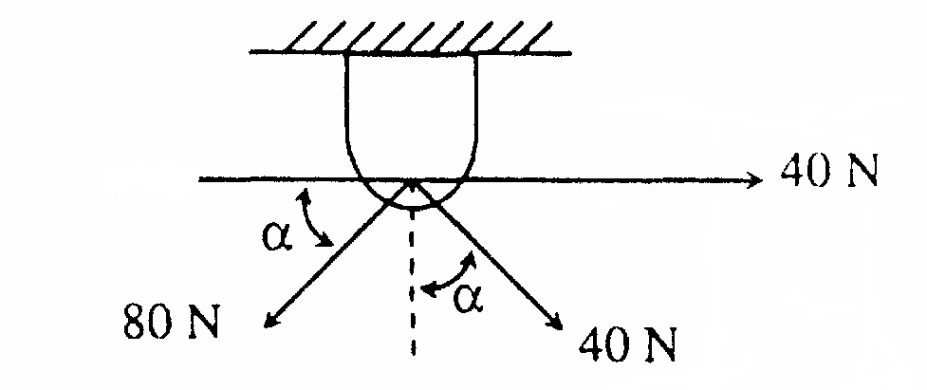

17. Determine resultant of following force system as shown in Fig.

(Ans: R = 8.38 N IIIrd quadrant, θ= 85.28° )

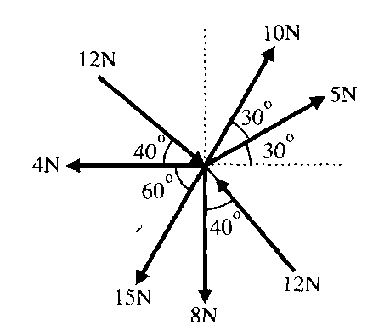

18. Three concurrent, coplanar forces act on a body at point o. Determine two additional forces, along OA and OB such that resultant of the five forces is zero.

(Ans: FOA = 453.66 N, FOB = 673 N )

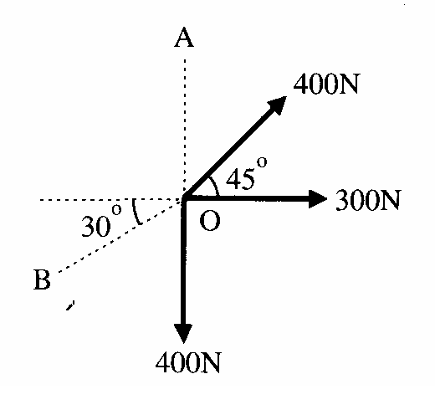

19. For given system determine (a) the required value of α if resultant of 3 forces is to be vertical (b) The corresponding magnitude of resultant.

(Ans: α = 21.8°, R= 229.29 N )

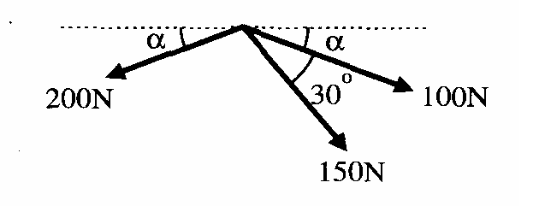

20. Determine the magnitude and direction of Force F1 and F2? When the Resultant of given force system is found to be 800 N along +ve x axis.

( Ans: F1 = 527.23, F2 = 1161.2 )

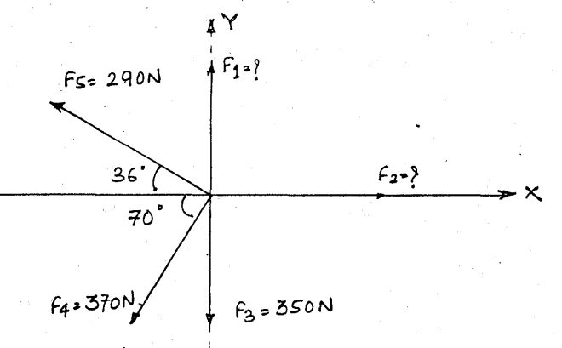

**Resultant of Non-Concurrent force system**

1. Find the magnitude and sense of the moment of the 800-N force about A.

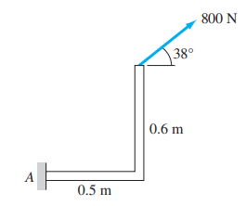

2. The three forces shown are equivalent to a 50-kN upward force at A and a 170-kNm counter-clockwise couple. Determine P and Q.

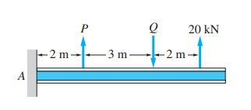

3. Replace the two forces shown by a force-couple system with the force acting at O.

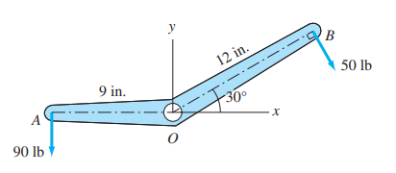

4. The coplanar force system in Figure consists of three forces and one couple. Determine the equivalent force-couple system with the force acting at point O.

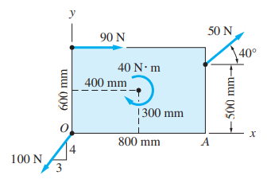

5. The force system acting on the machine part is equivalent to the single force R = 95i + 10j lb acting at O. Determine the force P and the distance b

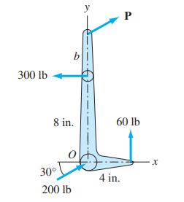

6. Replace the three forces with an equivalent force-couple system, with the force acting at O.

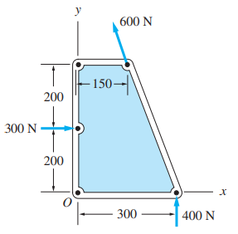

7. The force system shown consists of the couple C and four forces. If the resultant of this system is a 500-lb · in. counter clockwise couple, determine P, Q, and C.

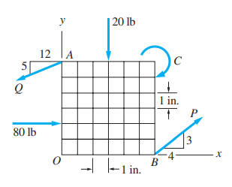

8. The overhead electric hoist C rides along a track on the horizontal beam AB. In addition to the 500-kN vertical force carried by the hoist, the beam also supports the three vertical forces shown. (a) If x = 5 m, determine the resultant of the four forces carried by the beam. (b) Determine the distance x for which the resultant of the four forces would act at the center of the span AB.

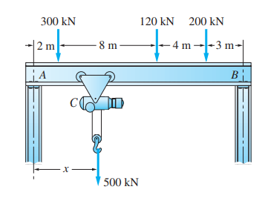

9. Determine the resultant of the line load acting on the beam shown in Figure.

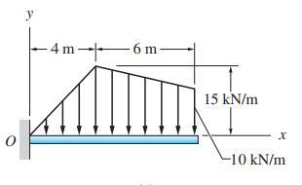

10. The resultant of the force-couple system acting on the frame is a force R acting at point A. Determine the forces P and R.

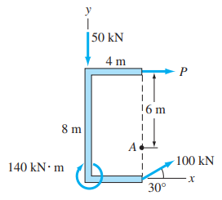

11. Three horizontal forces are applied as shown to a vertical cast iron arm. Determine the resultant of the forces and the distance from the ground to its line of action when (a) P = 200 N, (b) P = 2400 N, (c) P = 1000 N.

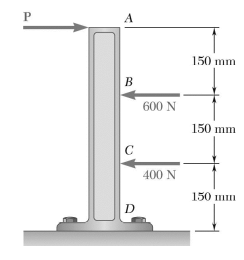

12. Four forces act on a 700 × 375-mm plate as shown. (a) Find the resultant of these forces. (b) Locate the two points where the line of action of the resultant intersects the edge of the plate.

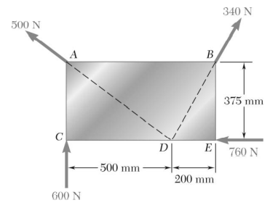

13. Three forces shown in Figure produce a horizontal resultant force through the point A. Find the magnitude and sense of P and F.

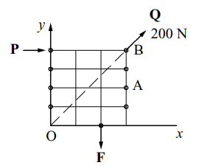

14. Determine the resultant of the four forces and one couple which act on the plate shown.

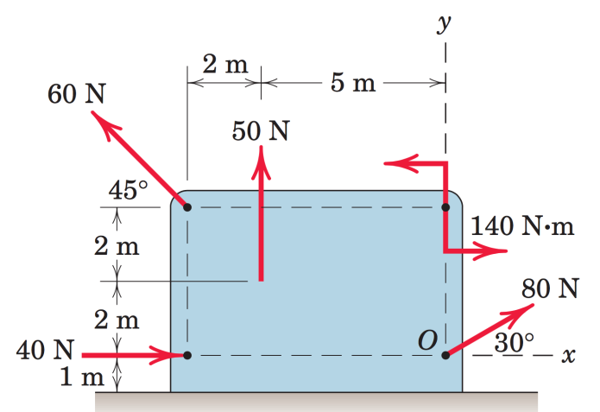

15. Four tugboats are used to bring an ocean liner to its pier. Each tugboat exerts 100kN push in the direction shown. Determine the point on hull where a single, more powerful tugboat should push to produce the same effect as the original four tugboats. Also determine the total push and its direction to be exerted by the single tugboat.

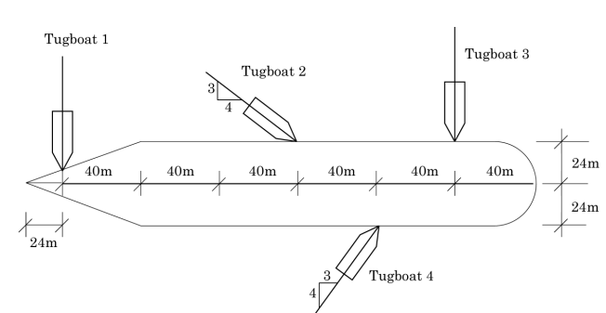

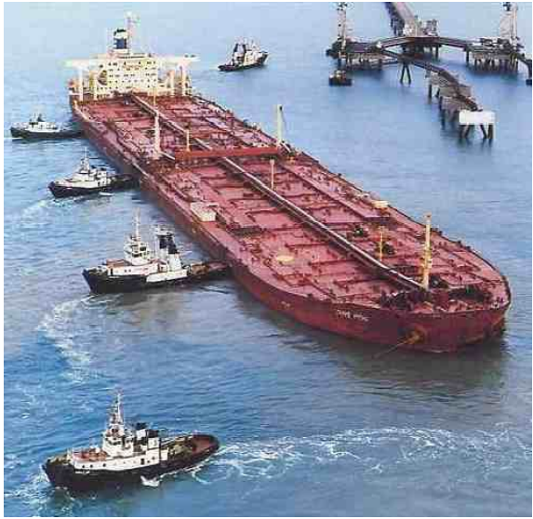

16. Find the simplest resultant for the forces acting on the simply supported beam.

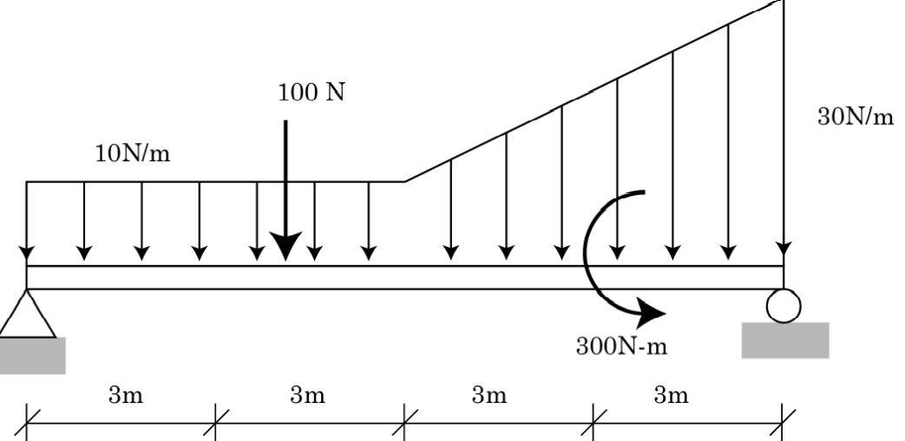

17. Determine the resultant of the non-concurrent, non-parallel system of forces shown in the figure.

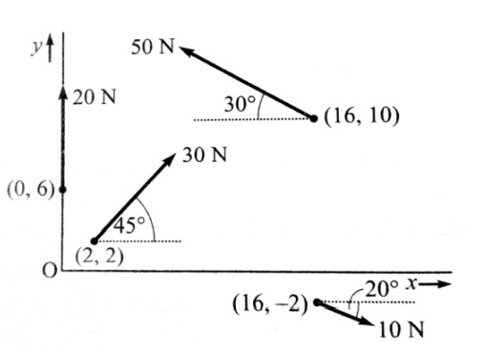

18. Determine the required magnitude of force F if the resultant couple moment on the frame is , clockwise.

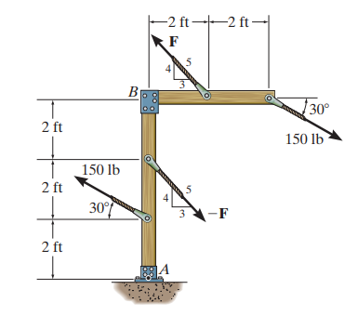

19. Replace the force and couple system acting on the member in Figure by an equivalent resultant force and couple moment acting at point O.

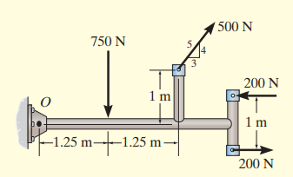

20. Replace the force system by a resultant force and couple moment at point O.

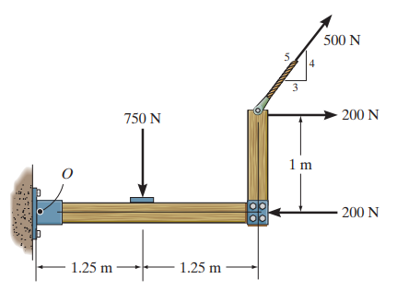

21. Replace the force and couple moment system acting on the overhang beam by a resultant force, and specify its location along AB measured from point A.

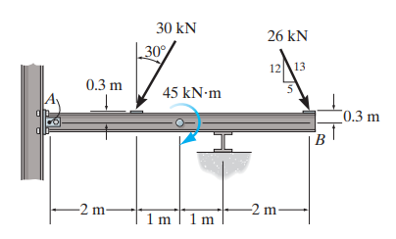

22. Replace the force system acting on the post by a resultant force, and specify where its line of action intersects the post AB measured from point B.

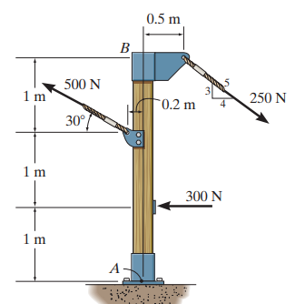

23. Replace the distributed loading with an equivalent resultant force, and specify its location on the beam measured from point A

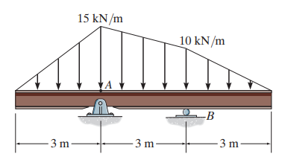

1. Find the position (x-axis intercept, y-axis intercept), magnitude and direction ‘θ’ of the resultant ‘R’ of only the active forces acting on the ‘A’—frame structure shown in the figure.

( Ans : R = 134.16, θ = 63.43°, x = 6, y =12 )

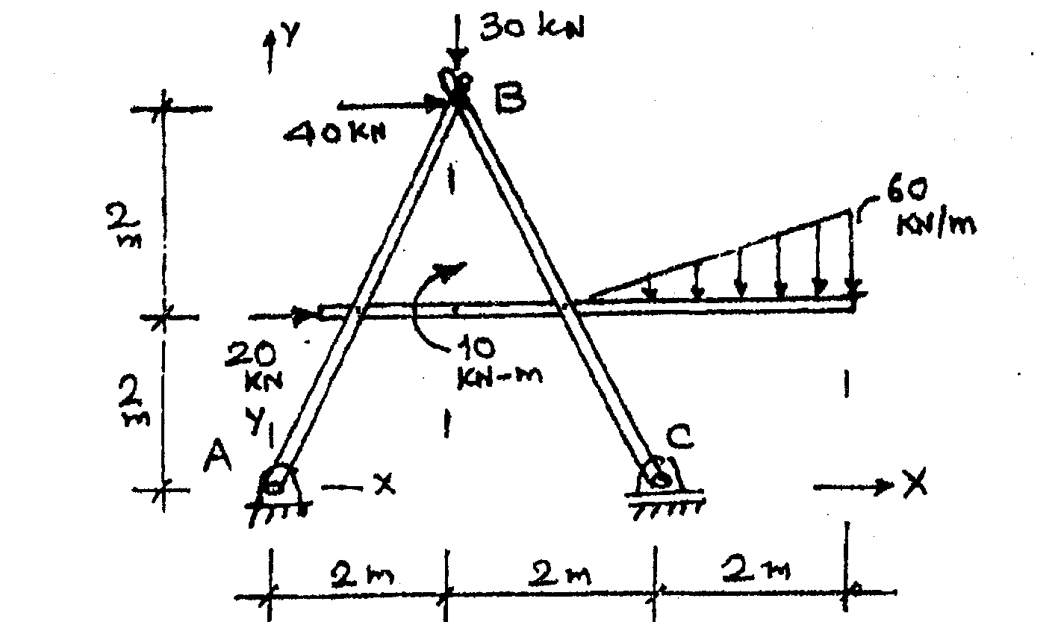

2. Determine the resultant of the given system of forces shown in Fig. Find the point of application of the resultant with respect to point C.

( Ans : Rx = 141.21←, Ry = 102.64 ↓, R = 174.57, θ = 36.01°,)

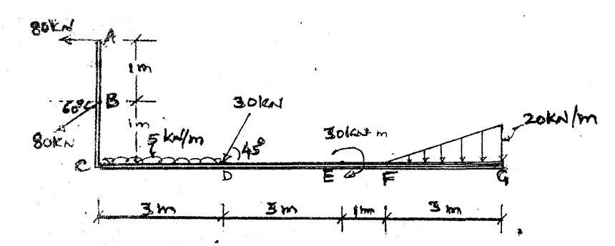

3. Find the resultant of forces acting on the bell crank lever shown figure.

( Ans : Rx = 145 →, Ry = 143.3 ↓, R = 203.86, θ = 44.66 °, a = 2.08 )

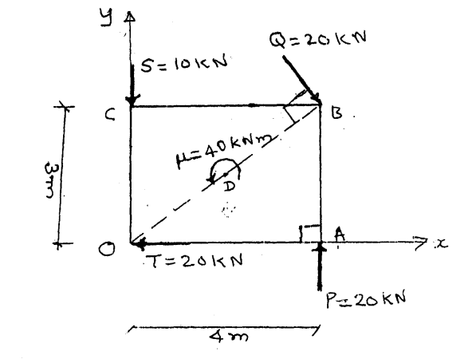

4. Find the resultant of the force system acting on a body 0ABC, shown in figure. Also find the points where the resultant will cut the X and Y axis. What is the distance of resultant from 0?

( Ans : Rx = 8 ←, Ry = 6 ↓, R = 10, θ = 36.87 °, a = 2 )

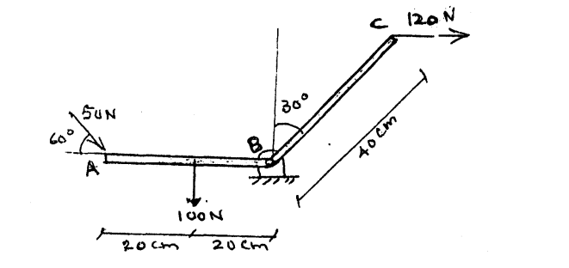

5. Replace the system of forces and couple by a single force couple system at A.

( Ans : Rx = 155 ←, Ry = 210 ↓, R = 261, θ = 53.57 °, Ma = 60 )

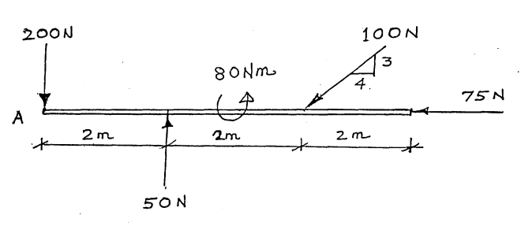

6. The forces acting on 1mlength of dam are shown in Fig. Determine the resultant force acting on the dam & the point of intersection of the resultant with the base.

( Ans : Rx = 24 →, Ry = 135 ↓, R = 137.19, θ = 79.92 °, X0 = 3 )

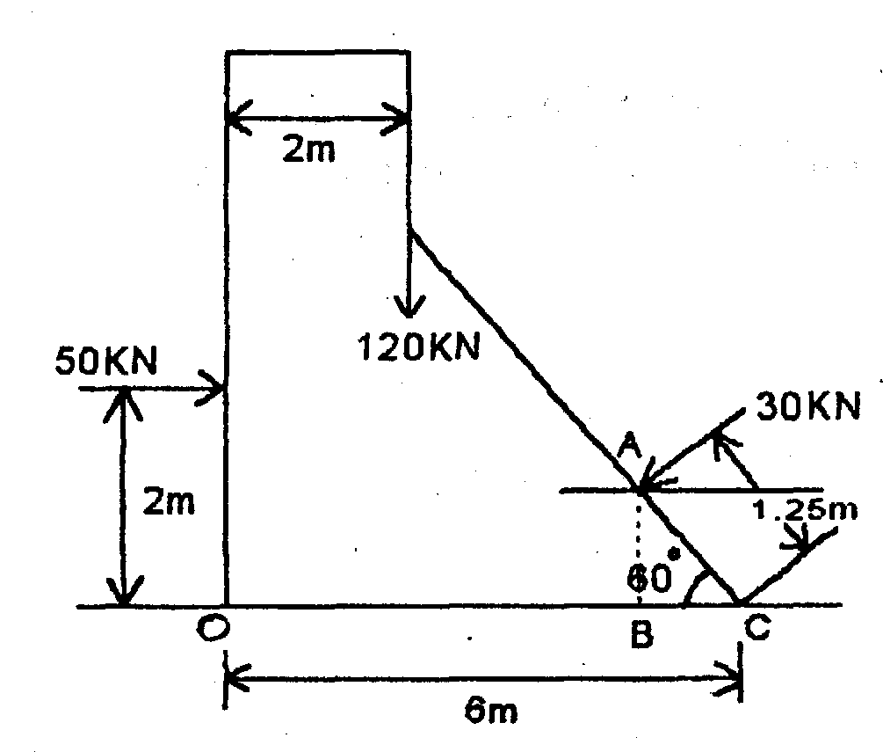

7. Find the resultant of co-planer force system given below and locate the same on AB with due consideration to the applied moment.

( Ans : Rx = 200 ←, Ry = 470 ↑, R = 510.78, θ = 66.94 °, a = 0 )

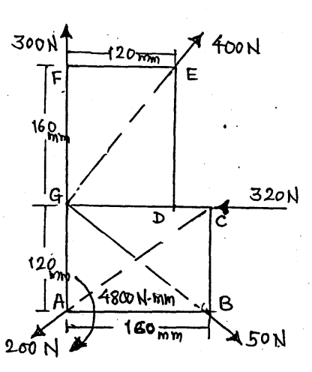

8. Determine the resultant of the following system of parallel forces and locate the same.

( Ans : R = 300 ↑, x = 9.25 )

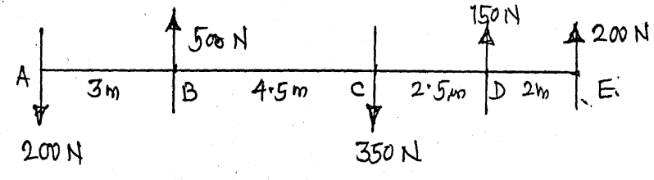

9. Determine the magnitude, direction and position of the resultant of the force system shown in figure.

( Ans : Rx = 11.13 →, Ry = 1941.72 ↑, R = 1941.75, θ = 89.67 °, a = )

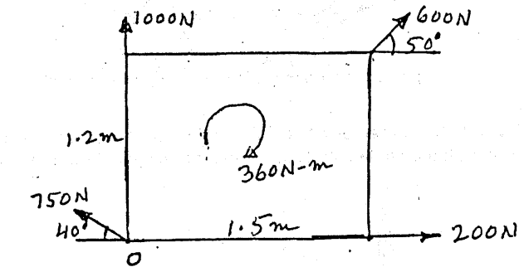

10. Determine resultant of the following parallel forces and locate w.r .t. ‘0’ radius Is 1 m.

( Ans : R = 80 ←, y = 2.08 )

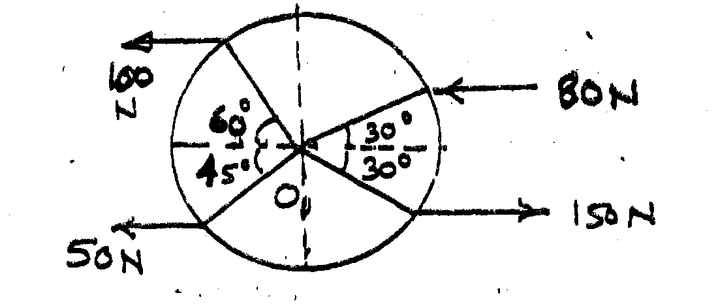

11. A bracket is subjected to a coplanar force system as shown in figure. Determine the magnitude and line of action from A of the single resultant of the system. If the resultant is to pass through the point B, what should be the magnitude and direction of couple?

( Ans : Rx = 250 ←, Ry = 367 ↓, R = 444, θ = 55.73 °, a = )

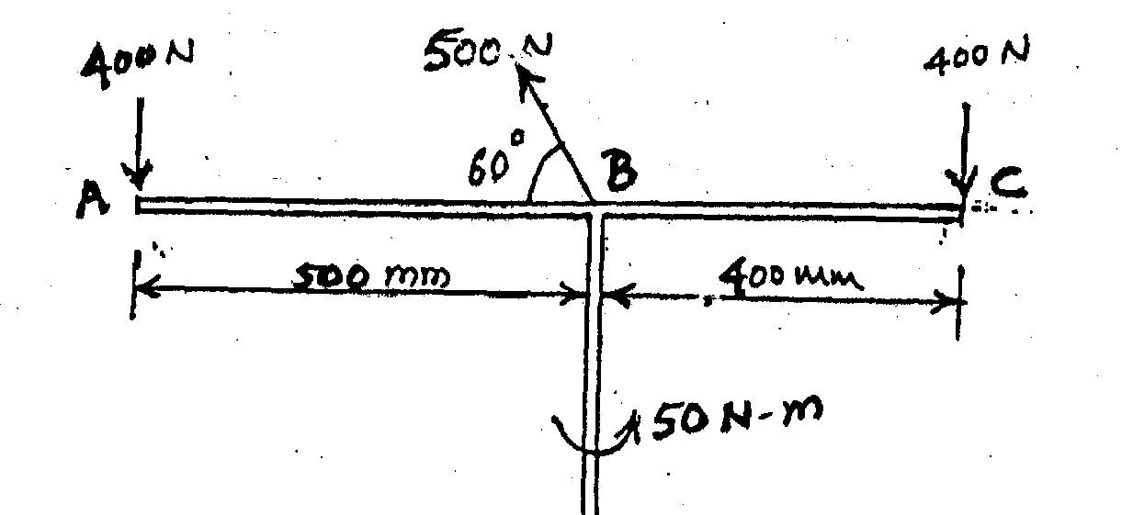

12. A square lamina is subjected to a force of P1 = 1580 N as shown. Calculate the values of forces P2 and P3 such that the resultant of the system of forces will be a horizontal force at point E.

( Ans : P2= 901.7, P3 = 1678.5 )

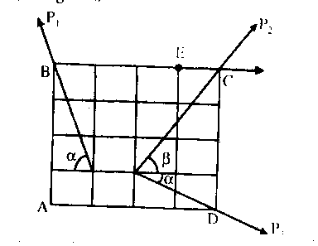

13. The resultant R of four forces, of which three are shown in Fig is 1950 N down to the right with a slope of 5 to 12 through point A. if P= 750 N, and F= 650 N, determine the missing force T and its X intercept.

( Ans : T = 901, θ = 33.7 °, x = 3.1 )

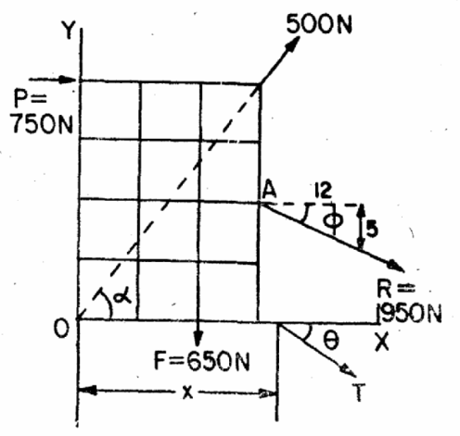

14. A member ABC is loaded by distributed load and pure moment as shown in the figure find the (i) magnitude and (ii) position along AC of the resultant.

( Ans : R =90 ↑ , XA = 23 )

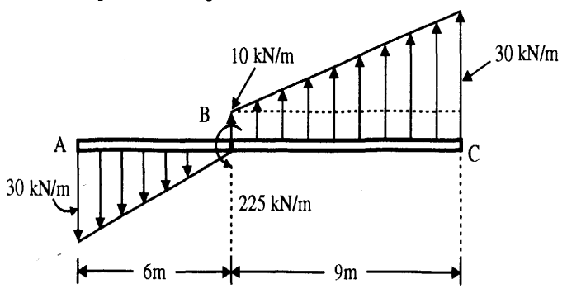

15. A fixed square board EFGH carries two pulleys A and B which carry loads of 20 N & 40 N respectively with the help of cables fixed at point K and J as shown as shown in the figure. The diameter of each pulley is 400 mm. With reference to x—y axis shown the co—ordinates of centers of pulleys are A (1, 4) and B (4, 1) m.

Find (i) Magnitude of resultant force on the board and (ii) x—axis intercept, y — axis intercept o the resultant forces.

( Ans : Rx = 24.64 →, Ry = 57.32 ↓, R = 62.39, θ = 66.74 °, x = 1.953, y = -4.544 )

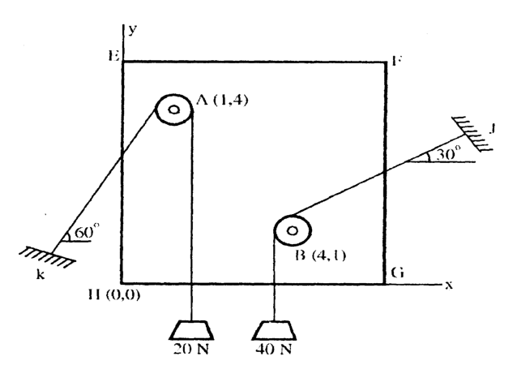

16. Replace the system of forces and couples shown in figure by a single force and couple at a point A. ( Ans : R = 75 ↓, C = 5.75 NM ACW )

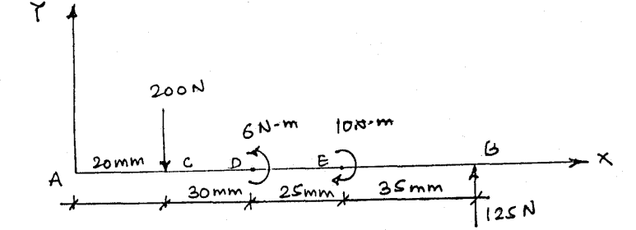

17. Determine the resultant of the non-concurrent, nonparallel system shown in Fig. Assume that the coordinates are in meters.

(Ans: R= 194 N, Ist quadrant, θ = 86°, a = 4.69 m)

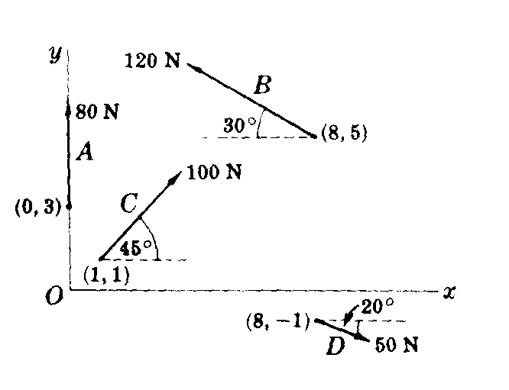

Three forces produce a horizontal resultant force through the point A. Find the magnitude and sense of force P and F

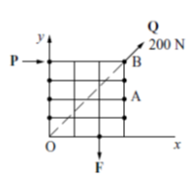

1 2 3 1 2 3

4 5 6 4 5 6

7 8 9 7 8 9